**1.**What are the two values of the Boolean data type? How do you write them?

**A.1**

1. True
2. False

**2.** What are the three different types of Boolean operators?

**A.2**

1. and
2. or
3. not

**3**. Make a list of each Boolean operator’s truth tables (i.e. every possible combination of Boolean values for the operator and what it evaluate ).

**A.3**

Truth table of **and** operator:

|  |  |  |
| --- | --- | --- |
| A | B | output |
| 0 | 0 | 0 |
| 0 | 1 | 0 |
| 1 | 0 | 0 |
| 1 | 1 | 1 |

Truth Table of **or** operator:

|  |  |  |
| --- | --- | --- |
| A | B | output |
| 0 | 0 | 0 |
| 0 | 1 | 1 |
| 1 | 0 | 1 |
| 1 | 1 | 1 |

Truth Table of **not** operator:

|  |  |
| --- | --- |
| A | Output |
| 0 | 1 |
| 1 | 0 |

**4.** What are the values of the following expressions?

1. (5 > 4) and (3 == 5)
2. not (5 > 4)
3. (5 > 4) or (3 == 5)
4. not ((5 > 4) or (3 == 5))
5. (True and True) and (True == False)
6. (not False) or (not True)

**A.4**

1. False
2. False
3. True
4. False
5. False
6. True

**5.** What are the six comparison operators?

**A.5.**

1. Greater than(>)
2. Greater than equal to(>=)
3. Smaller than(<)
4. Smaller than equal to(<=)
5. Equal to(==)
6. Not equal to(!=)

**6.** How do you tell the difference between the equal to and assignment operators? Describe a condition and when you would use one.

**A.6**

* Equal to operator(==) is used to compare to values, to check whether the value of left side and right side is equal or not.
* Assignment operator (=) is used to assign a value.
* For eg. Grade_A=90
  + Grade_B=80
* here we have used assignment operator to assign value of 90 and 80 to variable Grade_A and Grade_B respectively.
* Grade_A==Grade_B
* Here we have used equal to(==) operator to compare values of Grade_A and Grade_B which will return False.

**7.** Identify the three blocks in this code:

spam = 0

if spam == 10:

print('eggs')

if spam > 5:

print('bacon')

else:

print('ham')

print('spam')

print('spam')

**A.7.**

First Block:

if spam == 10:

print('eggs')

Second Block:

if spam > 5:

print('bacon')

third block:

else:

print('ham')

print('spam')

print('spam')

**8.** Write code that prints Hello if 1 is stored in spam, prints Howdy if 2 is stored in spam, and prints Greetings! if anything else is stored in spam.

**A.8.**

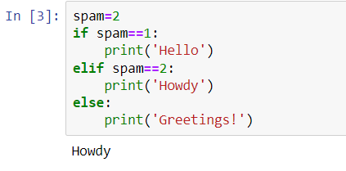

**9.**If your program is stuck in an endless loop, what keys you’ll press?

**A.9**. Ctrl+c or restart the kernel

**10.** How can you tell the difference between break and continue?

**A10.**

Break will end the loop if condition is True

Where as continue will not execute the following set of statements of current iteration of loop if condition meets.

**11.** In a for loop, what is the difference between range(10), range(0, 10), and range(0, 10, 1)?

**A11.**

No difference between all 3, all 3 are same thing.

**12.** Write a short program that prints the numbers 1 to 10 using a for loop. Then write an equivalent program that prints the numbers 1 to 10 using a while loop.

**A.12**

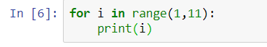

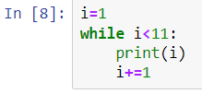

**13.** If you had a function named bacon() inside a module named spam, how would you call it after importing spam?

**A.13**

spam.bacon()